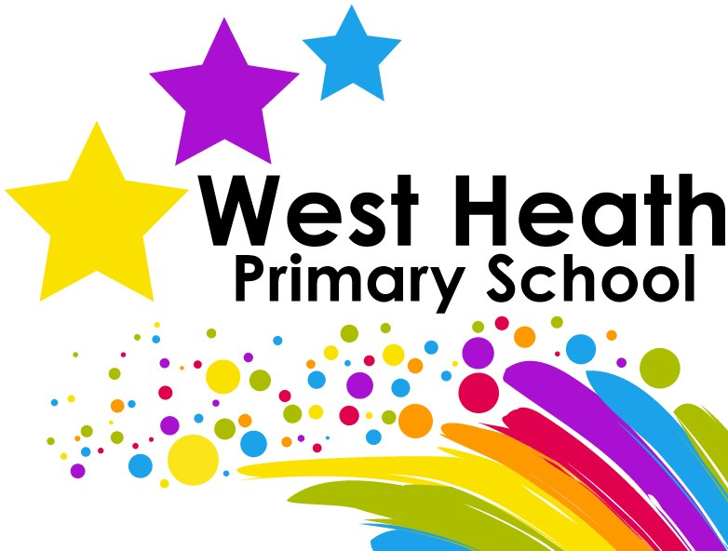

Curriculum Policy

Safeguarding Statement
West Heath Primary will continuously strive to ensure that everyone in our school is treated with respect and dignity. Each person in our school will be given fair and equal opportunity to develop their full potential with positive regard to gender, ethnicity, cultural and religious background, sexuality or disability. West Heath Primary School is committed to safeguarding and promoting the welfare of children and young people and expects all staff to share this commitment.

Owner | Headteacher
Date of review | July 2020
Date of next review | July 2021

Curriculum Policy

Audience
This policy has been written so that all staff follow our expectations for our interpretation of the National Curriculum.

Curriculum Intent
At West Heath there is a collective understanding that children learn best when they are inspired by their learning; when they are active and when they are physically and emotionally healthy. We have worked hard to develop an inspiring curriculum that equips our children with the skills and knowledge necessary to live as responsible citizens in modern Britain, we truly want our pupils to believe that anything is possible!

Our curriculum is mapped to include coverage of the National Curriculum and provides a range of experiences for our children. At West Heath we champion every child to, ‘Be a Star Shine Bright!’

Curriculum Implementation
At West Heath we have three curriculum drivers. These are the things that underpin our curriculum; the things we believe give our school its unique identity.
Our first curriculum driver is Physical Activity, which we passionately believe can play a crucial role in child development. We offer our children as many opportunities as possible to take part in an extensive range of sports, whilst also seeking out opportunities to include active elements in lessons across the entire curriculum.
Our second curriculum driver is Values Education, which also permeates everything we do. We believe that helping our pupils to develop strong values will give them the platform to go on and make a success of their future lives. As a school, we have seven values: collaboration, honesty, empathy, respect, resilience, determination and excellence. We teach children how to use and understand these values, so that they can grow into reflective individuals who make positive contributions to society and enjoy all the world has to offer.
Our final curriculum driver is Reading. As a school we have made a commitment to ensuring that every child will leave our school as a competent reader, regardless of their ability. This commitment to reading is evident in all aspects of school life.
These curriculum drivers are at the heart of our curriculum, along with the core subjects of English, Mathematics and Science. However, we also value our wider curriculum, and our curriculum covers all other National Curriculum subjects. We are committed to ensuring that our children are exposed to a wide and varied range of learning experiences. Our curriculum is designed so that specific knowledge and skills are scaffolded within a topic each half term. These topics are linked to a specifically chosen novel, upon which the children’s work in English is based. In order to ensure that progression and balance is maintained, the programmes of study have been developed into comprehensive curriculum maps, which clearly outline the skills and knowledge our children should gain. Teachers use these to generate medium term plans which clearly highlight the learning objectives, assessment opportunities, tasks as well as links to other subjects. Teachers translate these plans into daily lessons where the specific needs of the learners are addressed.

Curriculum Impact
We aim for all of our children to leave West Heath:
- Equipped with the skills and knowledge needed to be lifelong learners
- Believing that with hard work and determination, anything is possible
- To be respected citizens ready to make valuable contributions to social capital
- To understand the importance of leading a healthy lifestyle through physical activity and emotional wellbeing
- To read with fluency

Procedure for Maths
The school uses the White Rose Maths Hub scheme of work for maths. Teachers are provided with the curriculum overview and each unit’s additional guidance, by the maths coordinator at the start of the school year. This information can also be found on the school’s website.

Procedure for English
The school has a comprehensive plan for the teaching of English. Each term teachers have specific novels that are used as a stimulus for writing, these are related to the topic the class is studying. This plan clearly outlines the objectives to be covered in relation to spelling, handwriting, writing composition and grammar. This information can also be found on the school’s website.

Procedure for Non-core Subjects and Science

Long Term Planning
The whole school topic overview identifies what subjects will be taught in each year group on a half termly basis and gives a brief outline of the topic area. In addition to this topic overview, detailed curriculum maps for every subject are also provided to staff. This shows what knowledge and skills need to be taught and mastered each half term in all subjects. Teachers use this curriculum map to produce their medium-term plans. These maps are also available on the school website.
Example of year group Curriculum Plan

Curriculum section of the school website

Medium Term Planning
Teacher use the curriculum maps to guide their medium-term planning. Planning for each half term must be completed sent to the deputy head teacher on the first Friday of each half term. All medium-term planning must be completed on the schools agreed format as shown below and must be saved on the school system in the year group folder. A medium-term plan must be completed for each subject to be taught each half term, with the exception of Maths and English. This must include the differentiation for each lesson and clear success criteria.

Lesson | Learning Outcome | Brief Teaching Outline
1

The Literacy overview, including key focus for Grammar, Spelling, Punctuation and genre, will be provided. Teachers are expected to use the curriculum map to plan for weekly lessons.
- The Maths Programmes of Study will follow the sequence of lessons indicated in the White Rose Maths Scheme. Teachers are expected to use the Maths curriculum map to plan for weekly lessons.
- Science should be planned using Rising Stars and the lessons for the term should be planned for using the termly planning grid. The planning MUST include success criteria, focus values and differentiation.
- History, Geography, Art, D/T, Spanish, Music, and SRE should be planned using the school curriculum map. The lessons for the term should be planned for using the termly planning grid. The planning MUST include success criteria, focus values and differentiation.
- RE, ICT should be planned using the school curriculum map. Lessons for the themed day should be planned for using the termly planning grid. The planning MUST include success criteria, focus values and differentiation.
- The use of worksheets is not allowed unless there is no other way for children to access a resource.

Short Term Planning
YEAR 1- YEAR 6
- Daily planning for Maths and English MUST be planned using the grids in the planning file.
- All teachers are individually responsible for the planning and progress of children in their own class.

Planning must include the following bullet points: -

Head | Heart | Hands
- Learning outcome  - Success criteria  - Spelling focus words | Values to be focussed on | - Outline of what each child/group are expected to achieve.  - Differentiation by level of cognitive thinking and identify which group the teacher will be working with.  - The use of worksheets is not allowed unless there is no other way for children to access a resource.

Short term planning is completed on Active Smart Boards. The following images show what must be included. The pages model skills and knowledge to be shared with the children
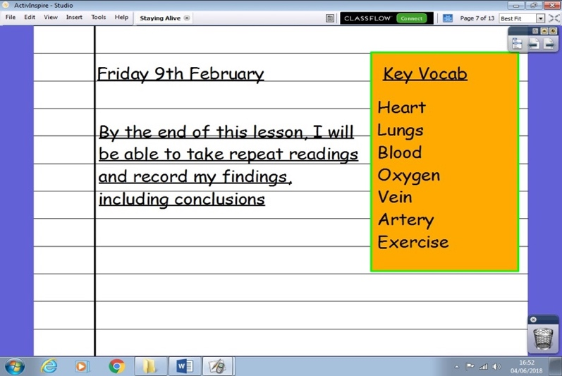

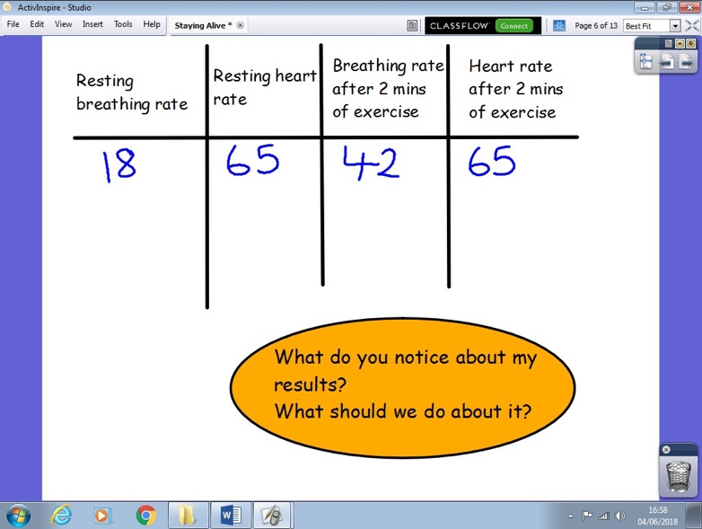

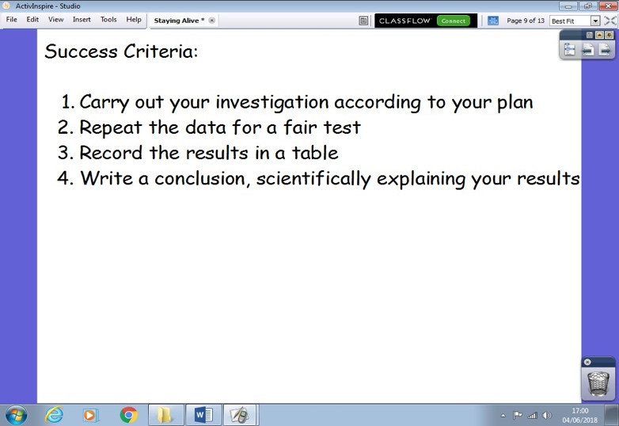

EARLY YEARS
Expectations for weekly planning
- Each week there must be a focus based upon a book from the recommended book list. This may be extended if the children are enjoying the book and there is scope for further development. It is appropriate to change the book if the children’s interests take the learning in a different direction.
- Planning MUST outline the specific focus for the children in all key areas. Planning should be shared with all members of the EYFS team.
- Planning MUST be mounted onto the planning whiteboard and annotated according to the children’s interests. There is no requirement to rewrite the sheet, it is a working document.
- The activities for the day MUST be shared with the children and the focus values MUST be shared every day. However, children’s interests MUST drive the curriculum and therefore activities planned by the children must supersede adult led planning, should the need arise.
- Phonics planning should follow the expectations as laid out in the RWI scheme.

Expectations for weekly resourcing (in addition to continuous provision resources)
- Resources appropriate to the ‘story’ MUST be available each week in order that the children can access equipment to foster their imagination. Adults should pre-empt (as much as is reasonably practicable) the type of resource children might request.
- A collection of basic resources MUST be available for the children to easily access and should be replenished weekly (paper, string, scissors, boxes etc.)
- Pencils, in all areas, MUST be sharp.
- Books in all areas MUST be neatly and appropriately displayed and be appropriate to the age/stage of the children in EYFS.
- All resources are expected to be of a high standard and be readily available to children to access independently.
- All resources MUST be appropriately labelled with the number of items, colours, shapes, sizes appropriate the age and stage of the children. Resources MUST be changed regularly to meet the requirements of the ELG.
- All resources MUST have an identified space within the room which is understood by children.
- Any labels around the room MUST be accessible to children and should only be used if the children can read them or decode them.

Timetabling
The following outlines the minimum amount of time to be spent on curriculum subjects:
- I hour of maths a day
- I hour of literacy a day
- 30 minutes of guided reading a day
- 90 minutes of science a week
- 30 minutes of Spanish at KS2 a week
- 2 hours of PE a week
- 30 minutes of circle time
- 3 hours of topic lessons
- 45 minutes of phonics in Y1
- 20 minutes of spelling
- 1 RE day per half term
- 1 PSHE day per half term
- 1 Computing day per half term

In addition to this, all classes take part in the daily mile.

Presentation
- Pencils MUST be sharp for all pieces of work.
- Teacher handwriting must be legible and teacher spelling or grammar errors must not be evident in any children’s work.
- Work which requires a tick or a cross MUST be acknowledged neatly and with care.
- All staff spelling MUST be correct.
- All staff letter formation MUST be correct.
- Children MUST be expected to hold their pencil correctly.
- Letter formation MUST be correctly modelled by all members of the EYFS team, on every resource.
- The short date should be written in all books, except for English, where the long date is expected. It is expected that the date is correctly spelled.
- There is no requirement for the children to write the LO; they must however write an appropriate title. This must be underlined, with a ruler and it is expected that the title is correctly spelled.
- A handwriting pattern (that is the handwriting focus of the week) MUST be used at the end of EVERY piece of work (except Maths.) Coloured pencils MUST be used for handwriting patterns. Pencils must be sharp.
- Children should only cross their work out with a straight line, using a ruler.
- Teachers MUST use the marking grid as outlined on the classroom charts and in the Marking Policy.
- All staff handwriting MUST be legible.

Exercise Books

- Daily Literacy will be recorded in Literacy Books. In these books, children should miss a line between their writing. A handwriting pattern must be used at the end of every piece of work.
- Final drafts of writing will be recorded in Creative Writing books. A title can be written instead of the learning outcome.
- Maths work will be completed in Maths books. One digit is to be written in each box.
- Topic books will be used for Topic lessons and must show the same expectation for presentation and content as in Literacy and Maths books. A handwriting pattern must be used at the end of every piece of topic work unless work is on plain paper such as a diagram, map.
- Science books will be used for Science lessons and must show the same expectation for presentation and content as in Literacy and Maths books. A handwriting pattern must be used at the end of every piece of topic work unless work is on plain paper such as a diagram, map.
- A new page must be started for each new lesson.
- It is unacceptable for the date and learning outcome to be the only thing written on a page.
- In Topic books and Science books it is acceptable for the short date and a title to be recorded instead of a Learning Outcome, but evidence of assessment against the success criteria must be seen.
- Marking must also relate to the learning outcome, not the title!
- In KS1 it is acceptable to glue the date and LO into children’s books. It is also acceptable for a title and short date to be written by the children in all books!
- Any work glued into a book must fit neatly onto a page and must contain the date and LO/title as appropriate.
- Worksheets must not be used as a substitute for writing and should only be used if it is the only way to present a task to children. Worksheets containing one-word answers are not allowed! Children are expected to write in full sentences, at every opportunity.
- If there is doubt about a worksheet, seek clarity from the Head teacher or Deputy Head Teacher.
- All books must contain a clean label with the child’s name, class and the subject on the front.
- A red circle should be placed in the top right-hand corner of the front to signify that the child is entitled to pupil premium funding.
- A green circle should be placed in the top right-hand corner of the front cover to signify that the child is on the SEND register
- Marking is used for assessment purposes and also to generate feedback to children in order that they know how well they have done and what they must do to improve.

Marking
- Teachers are responsible for all marking. Where this is delegated to a Teaching Assistant, the teacher must check the marking, including correct use of English grammar, spelling and handwriting. When a Teaching Assistant marks work, they must initial the marking.
- Teachers may mark in any colour other than black or blue.
- The marking symbols given below must be used.

Incorrect SPELLING | _____ | Underline the incorrect word/ Teacher write the correct spelling above
Incorrect use of PUNCTUATION | , | Circle around the letter /mark
Start a PARAGRAPH | // | Next to the place where the paragraph should start
SUPPORTED WORK | S | At the end of the work
VERBAL FEEDBACK | VF | Next to work
INDEPENDENT WORK | I | At the end of the work
Incorrect answer | x | Next to the work
Correct answer |  | Next to the work
Peer Assessment | PA | This must also be acknowledged by a teacher

Spelling
- Only the focus words should be identified within children’s writing.
- Children are expected to write the correct spelling at the end of their work.
- The marking symbol to identify incorrect spelling should be used instead of over writing.

Values
- At the end of each piece of work, there should be acknowledgment of the value the children have shown.

Success Criteria
- Children should assess their own work according to the success criteria.
- From Y2 to Y6, it is appropriate for the success create to be numbered and for children to self-assess with  or x.
- A basic requirement of all writing activities is that the final success criteria encourages children to assess their own work against their writing target (i.e. I have met my writing target! I have used my writing target.)

Additional Information
- In the case of staff absence, work must be acknowledged with the word Supply at the end.

Homework
Reading
- All children should read every evening for 10 minutes. Parents should ensure that the Reading section of their child’s Passport is completed each school night.

Spellings
Homework should be handed to the Class Teacher for marking, on Tuesday every week.
- Children will be given weekly spellings to learn. All children are expected to write a full sentence for each of their spellings.

Mathletics
- Teachers will set a Mathletics online activity each week. This activity should reflect a concept being taught in class or revise prior learning.
- Homework should be set on a Thursday and children are expected to complete it by Tuesday.

Times tables
- All children will be expected to learn their times tables each week.

Accelerated Reader
From Year 2 to Year 6, the children will take part in the Accelerated Reader Programme.
- At the beginning of each term, the children will complete a Star Reading Assessment, which will give them a score.
- The score will be used to decide which level books the children can take home.
- When a child completes a book at home, they will take an online quiz, which relates to the book they have read.
- These quizzes will take place during school time. Each class will have iPad, which the children will use to complete the quizzes.

The web address for our school’s account is as follows: This link will take the children to the log-in page where they can enter their personal log-ins. Pupil engagement and performance will be closely monitored.
http://ukhosted5.renlearn.co.uk/2232876

Assessment
Maths and Reading
Assessment Weeks take place in November, March and July. This equates to once a term. During these assessment weeks, Progress in Reading (PIRA) and Progress in Maths (PUMA) tests are conducted. These are marked by the teachers and the raw score converted to a standardised score. Children who are on track to achieve the end of key stage expectations in terms of attainment, should achieve a standardised score of 100. Children who gain a score below 100 are working below the expected standard for their year group at that point in time and those scoring more than 115 are classed as working at greater depth. The scaled scored from these assessments must then be uploaded to classroom monitor.
In addition to PIRA and PUMA assessments, accelerated reader is also used within the school. During September, all children in year 2 to 6 undertake the STAR reading assessment. These results of these
are also uploaded to classroom monitor.

Once all results have been uploaded onto classroom monitor, teachers use this information to make a ‘point in time’ judgement as to how each child is performing. Teachers will judge if the child is off track, on track, or above track.
These Results of these assessment will be analysed by the English, Maths and Assessment coordinator. These results will be used to complete year group analysis sheets that indicate both the attainment of the year group and the amount of progress they are making. These will be used to identify children that are falling behind that are the target for intervention. Along with the year group analysis, an analysis of significant groups will also be conducted, and the results reported to all staff and governors.
Writing
Teachers use a range of evidence to assess children’s writing. Writing is assessed using the end of year expectation for each year group. Termly, teachers complete a comparative judgement of all children’s writing in the year group and agree the cut off points those children working below the expected standard, at the expected standard and at greater depth within the expected standard. This is recorded on classroom monitor and progress mapped according to the following table. Teachers complete moderation sheets for every tenth child from the comparative judgement. These moderation sheets are ratified by year group partners. These results will also be recorded as point in time judgements on classroom monitor.

Monitoring
This policy will be reviewed biannually by the Senior Leadership Team and monitored by the Governing Body through the Curriculum Standards Teaching and Learning Committee.

