Mathematics Policy
Safeguarding Statement
West Heath Primary will continuously strive to ensure that everyone in our school is treated with respect and dignity. Each person in our school will be given fair and equal opportunity to develop their full potential with positive regard to gender, ethnicity, cultural and religious background, sexuality or disability. West Heath Primary School is committed to safeguarding and promoting the welfare of children and young people, and expects all staff to share this commitment. Please also refer to the
No Platform, Visiting Speaker Policy.

Owner – CSTL
Date of review-November 2020
Date for review – November 2022

Mathematics Policy

Audience

This policy is designed to be used by teachers at West Heath Primary School to ensure that the expectations for the teaching of Mathematics are clear.

Equal opportunities

At West Heath Primary School, we will continuously strive to ensure that everyone in our school is treated with respect and dignity. Each person in our school will be given fair and equal opportunity to develop to their full potential with positive regard to gender, ethnicity, cultural and religious background, disability or sexuality.

Aims

In line with the National Curriculum for Mathematics 2014, at West Heath Primary School we aim to ensure that pupils:
- Have fluent arithmetic skills appropriate to their age and stage which they can use to solve a variety of problems.
- Have a sound understanding of calculation, number, shape, space and measure and handling and interpreting data.
- Develop the ability to solve mathematical problems, presented in a variety of contexts
- Have a positive attitude to Maths.

Procedure

EYFS
Mathematics within the EYFS is developed through purposeful, play based experiences and will be represented throughout the indoor and outdoor provision. The learning will be based on pupil’s interests, Development Matters / Early Years Outcomes. Mathematical understanding can be developed through stories, songs, games, imaginative play, child initiated learning and structured teaching. The environment in EYFS has been set up to ensure progressive development of mathematical skills. Short Maths inputs are given daily to introduce new concepts and implemented into provision. Classroom equipment is labelled to show the quantity, shape, size (or a calculation) and children are expected to ensure the correct number of items are returned to their place at tidy up time.

KS1 and KS2

All children receive a daily Mathematics lesson, although mathematical skills run through many other areas of the curriculum. Each lesson has a clear learning outcome which all children are expected to achieve; extension activities enable those children who grasp the objective rapidly, to extend their learning by exploring it at greater depth. Teachers use the White Rose Maths Hub planning to produce their weekly smart boards. Whole class teaching is adopted and children work in mixed ability groups or placed into ability sets within their year groups. Every classroom has a range of practical apparatus to support children’s learning, additional resources are stored centrally.

Medium Term Planning

Medium Term Planning is given to all teachers at the star of the year. This comes from The White Rose Maths Hub. The planning gives teachers a yearly overview showing all topic areas to be covered in the year and the amount of time to be spent on each one.

Figure 1: Long term teaching overview
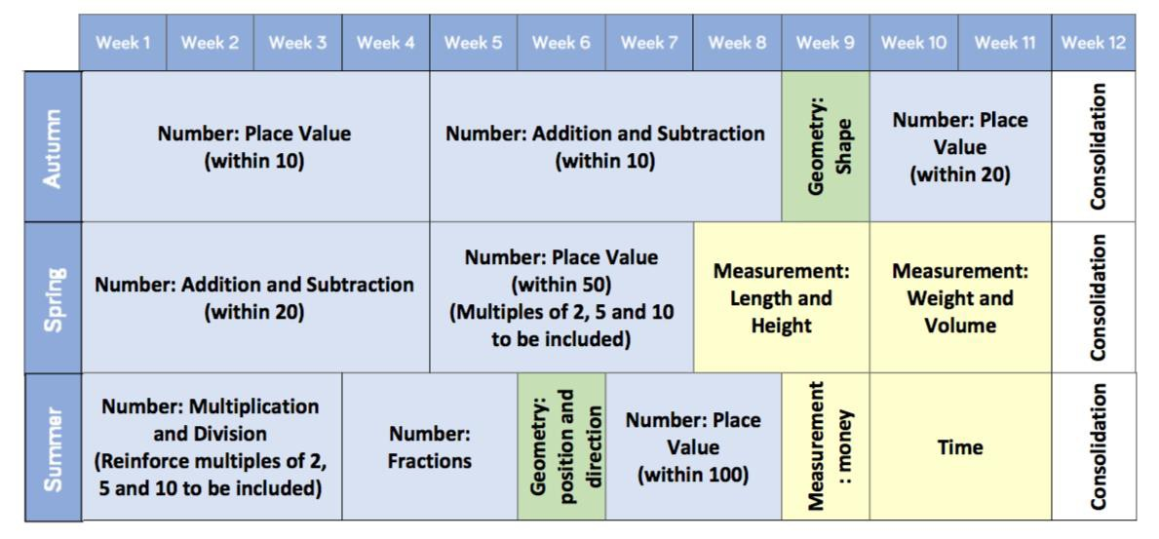

In addition to this long-term overview, teachers are given individual units of work, taken from the White Rose Hub. Each unit of work contains a breakdown of step; this identifies the teaching steps and the recommended amount of time to spend on each one. These small steps ensure that teachers do not teach too many concepts at once and which can lead to cognitive overload.

Figure 2: Small steps guidance
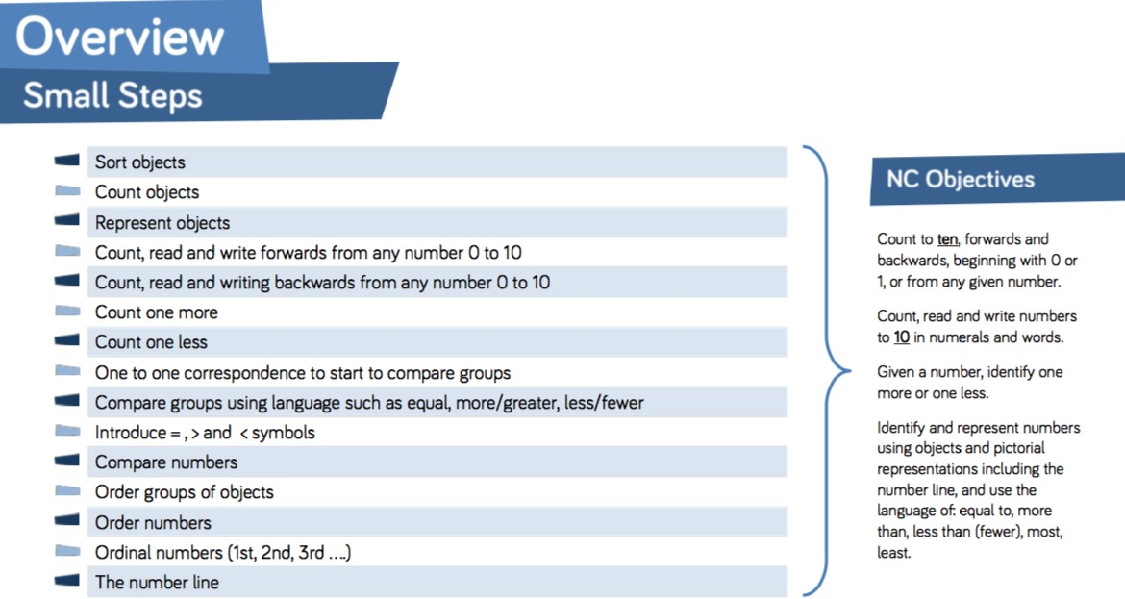

The scheme also gives clear teaching guidance and ideas for mathematical talk, varied fluency, reasoning and problem solving. Teacher are encouraged to use the ideas given by White Rose Maths Hub to plan their lessons.

Figure 3: Teaching guidance
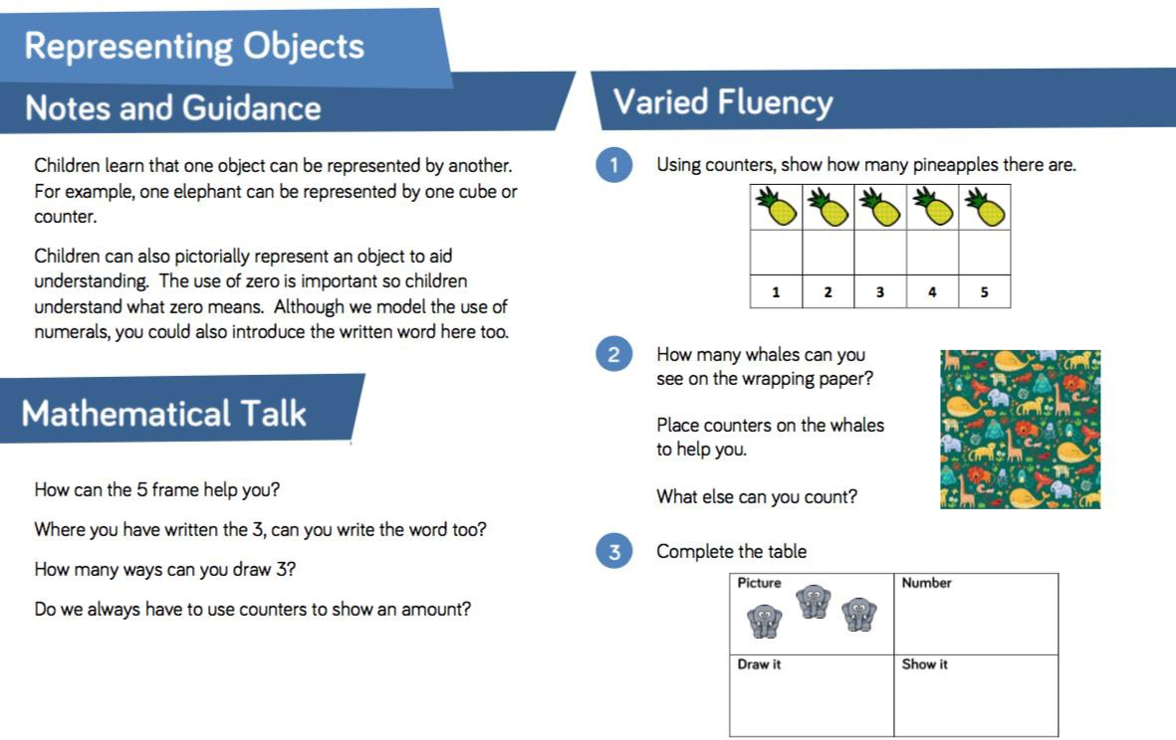

Short Term Planning
Teachers are required to produce Short Term Planning based on the Medium-Term Planning. The planning is to be produced on flipcharts and then saved on the system at the beginning of the week. This should include dates, learning objectives, key vocabulary, key teaching principles and differentiated learning opportunities for the pupils.

Assessment
Children should receive regular feedback during every lesson. This immediate verbal feedback should address misconception and provide opportunities for pupils to deepen their understanding of a topic. Groupings in class should be fluid to ensure that children are constantly challenged.
The assessment of pupils is ongoing; class teachers ensure that assessment informs future planning. Teachers mark work in Mathematics in line with the school’s Marking Policy.

Summative assessment

In October, March and June of each year, children will undertake PUMA standardised Mathematics tests. Following these tests, standardised scores will be calculated. Gaps in learning will be identified and interventions will be planned in order to ensure progress for all children. Effective use of pupil premium funding will be evaluated following each round of assessment. Provision for SEN pupils, LAC and those with EAL, will be evaluated termly.

Moderation

Teachers regularly moderate children’s work to ensure accurate teacher assessments. A file for this purpose which exemplifies work at the expected standard, below the expected standard and at greater depth within the expected standard, is held by the Maths Coordinator. The folder is updated termly and books which exemplify the expectation are kept at the end of the academic year.

Marking
In line with the school’s Marking Policy all work produced in Maths must be marked. Teachers are also expected to give verbal feedback during lessons and model the correct methods to pupils.

Presentation
All work in Maths should be presented in the following way:

- All pages in the workbook will have a margin
- The short date must be written at the top of the piece of work
- The learning outcome must be recorded in the book and underlined with a pencil and ruler
- In KS1 and Early Years it is acceptable for the date and learning outcome to be glued into books
- When writing numbers only one digit should be recorded in each square of the Maths book
- When drawing tables, and graphs a ruler and a pencil must be used
- Where worksheets have been used, they must be trimmed and securely glued into the children’s books neatly
- The front cover of every child’s book must display the child’s full name, class and the subject- MATHS. A red circle should be placed in the top right-handed corner of the cover to identify that the child is entitled to pupil premium funding. A green circle should be placed at the top-right hand corner of the cover to identify if the child is on the SEN register.
- Children’s work in workbooks must be of the same standard as expected in exercise books.

Tackling Tables
Tackling Tables has been introduced and takes place on a weekly basis. This helps children learn and improve their times tables fluency. Children are baselined at the start of the academic year to establish which colour they should be place upon. The colours represent the times tables as shown below: -
- Blue = 2, 5 and 10 times tables
- Green= 3,4 and 8 times tables
- Red = 6,7,9, 11 and 12 times tables
Children play the Tackling Tables card game daily and are tested weekly on multiplication and division. Tests are administered online using IPads and the scores are recorded on a spreadsheet to show progress. Teachers are expected to monitor this and teach misconceptions so as to close any gaps identified, Children who surpass the initial three stages will then complete work on missing numbers, multiples, fraction, decimals and percentages.

Homework
Homework in Maths is directly linked to Tackling Tables. Teachers send home the correctly coloured multiplication and division sheets on a Thursday. These are completed by the children and returned to school the following Tuesday. If a child does not complete their homework, a strike is issued in- line with the Passport Policy. Teachers are expected to meet with parents to discuss issues with homework. Times tables are crucial for progress in Mathematics.

Resources
All classrooms have maths resources appropriate to the age of the children. Children should be able to access these resources independently. It is expected that teacher plan lessons that use a range of resources.

Monitoring

Compliance with this policy will be monitored through lesson observations, work scrutiny, pupil voice and learning walks.

