Firstly, I want to say ‘thank you’ from the bottom of my heart to all of my colleagues, governors, our amazing children and their amazing families. The dedication shown in supporting and teaching our West Heath Primary School children has been incredible.

I know that some of you will have found it hard with your children being at home for so long; I also know that some of you have embraced lockdown and enjoyed watching the way your children learn.
We have all changed the way we work; we have become experts at webinar training, weekly Zoom staff meetings and virtual governing body meetings. It has been a journey!
We all know that we will not be returning to how things were before the pandemic. We have all learned lessons from it and something good always comes out of something bad! This has been the biggest challenge in many of our lives but as our school staff say …’There’s nothing we can’t do!’
This summer will be recorded as one of the most significant periods in history across the world! No one knows what the ‘new normal’ looks like but we will do what West Heath Primary School does best, work together to find solutions and we will create our own ‘normal!’
Have a lovely summer everyone… from Mrs Hooper

Some of our younger children want to remind you all of a few things to think about as we start our summer break.

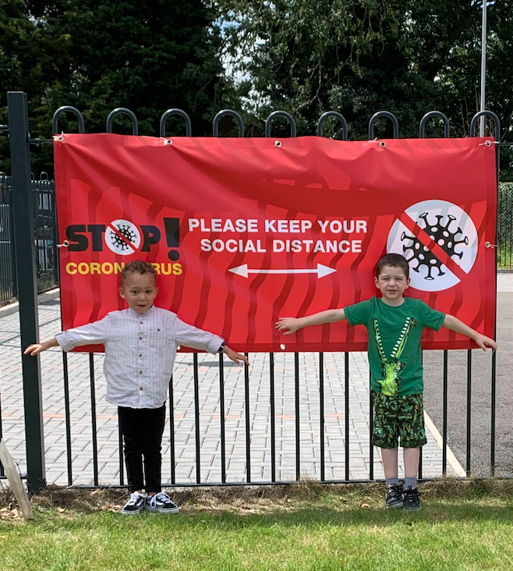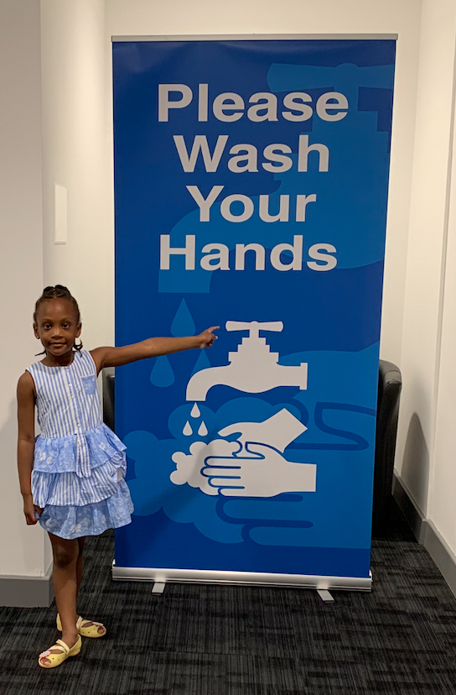
John Muir Award
Congratulations Y6, you have all passed your John Muir Award. This is a great achievement; we will send your certificates to you in the post. Well done, we are really proud of you all!
Don’t forget to…
PARENTS
Parents, you have been truly amazing during these difficult times. We would all like to ‘thank you’ for the support you have shown, it has made this whole adventure more bearable. We are praying that there will be no more school closures and we will do everything we possibly can to make the school a safe place to learn. Undoubtedly, the first few days in September will see many changes; our plan appears to work, on paper; in practice there maybe a few ‘tweaks’ to procedures. Regardless of any changes, however we want to reinforce social distancing outside of the school gates and on the school site. This will be strange for all of us and the thing that is giving us sleepless nights! We know however that as always, we will find a way to make this work together and to get your children back to school safely.

GOODBYE to the Class of 2020
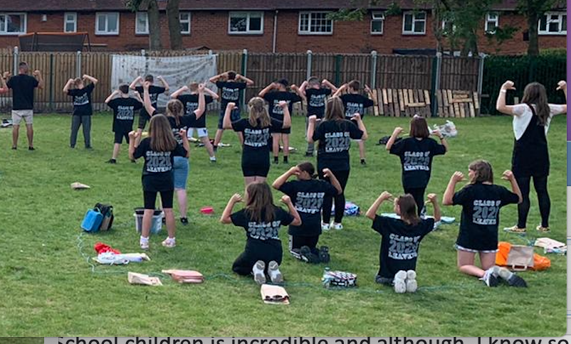
This week we said ‘goodbye’ to Year 6. For those Year 6 children who have not been back to school, we want you to know that we have thought about you every day and we will be sending your leaver’s t-shirts to you in the post.

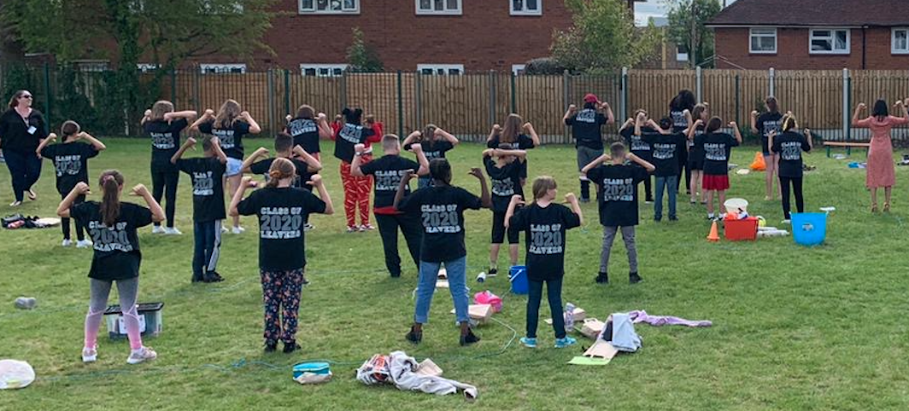
When it is safe to do so, we would love to see you all in your new secondary school uniforms.

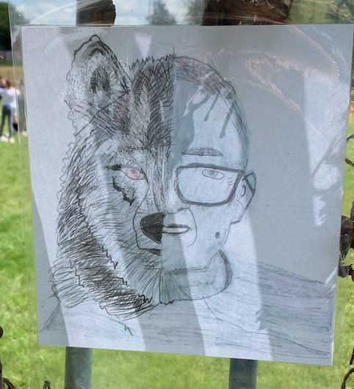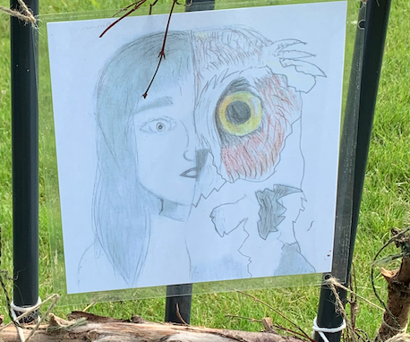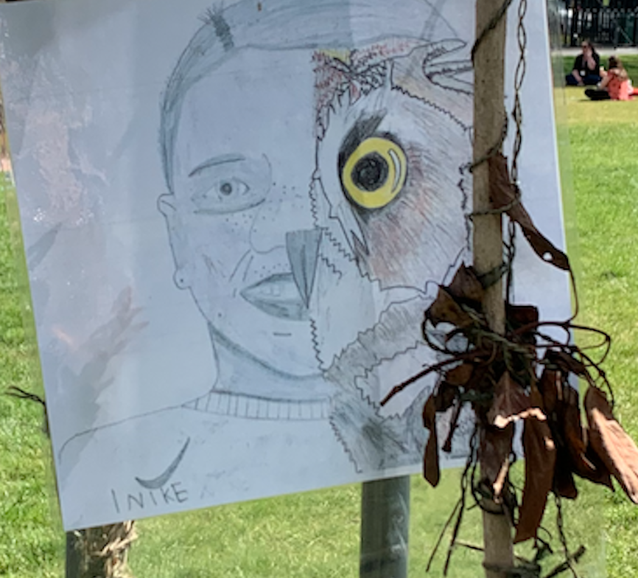
Those Year 6 children who have been back at school will leave a legacy behind. They have created forest school from a patch of overgrown grass to a fantastic learning environment. Their transition work has been brilliant! It is such a shame Year 6 that you weren’t able to attend your residential trip or perform a leaver’s assembly, but your picnic and ‘challenge’ day were lovely, and the ice-cream was delicious!

PE timetable from September
The PE timetable is below, this should help you to prepare for next year. Please note, your children will be doing PE on two different days this year; they will have to wear PE kit on both days.
Monday | Class 7  Indoor | Class 8  Indoor | Class 9  Outdoor | Class 10  Outdoor | Class 13  Indoor | Class 14  Indoor
Tuesday | Class 5  Indoor | Class 6  Indoor | Class 1  Indoor | Class 2  Indoor | Class 11  Outdoor | Class 12  Outdoor
Wednesday | Class 3  Indoor | Class 4  Indoor | Class 7  Outdoor | Class 8  Outdoor | Class 9  Indoor | Class 10  Indoor
Thursday | Class 3  Indoor | Class 4  Indoor | Class 11  Outdoor | Class 12  Indoor | Class 13  Outdoor | Class 14  Outdoor
Friday | Class 5  Indoor | Class 6  Indoor | Class 1  Indoor | Class 2  Indoor
REMINDER
Only children in Year 5 and 6, who have been given written permission to walk home on their own, will be permitted to bring a phone into school. However, parents should note that West Heath Primary School will not take responsibility for mobile phones. The phone must not be used on site and must be turned off before entry to school. The phone must then remain in the child’s drawer until home time.

REMINDER
All children in EYFS, Year 1 and Year 2 will be provided with a free school meal every day, therefore they do not need to bring a lunchbox into school.
Children entitled to free school meals do not need to bring a lunchbox into school, food will be provided.

To our amazing children
Well the school year is now over. What a year it has been! The next time we open our school gates you will be here; we really cannot wait! Your classrooms are waiting for you, we have all of your new resources ready and the curriculum your teachers have planned, is really exciting.

The Coronavirus will still be with us, but we will do our very best to keep everyone safe. We have loads and loads of cleaning equipment, lots of hand washing soap, antibacterial gel and wipes are everywhere. During the school holidays, we will be cleaning again and having a special cleaning treatment, which will put a film over all of our equipment to limit the number of germs we spread. Our lovely settees and chairs have been put into storage and all of our library books have been put into classrooms. BUT the school is still lovely, and Mrs Hooper is delighted because it is so clean!

What we really want to say to you is that this is still our school; all of your adults love you and on your first day back they will be so excited to see you! Everyone will be waiting for you to say ‘Hello!’ We think it is going to be a very emotional time, but we cannot wait!

REMINDER
Children will not be allowed to bring back packs or bags into school. We will provide children with a string bag on the first day back in September. Bags will be taken off children and sent home if they are brought in to school.
Children must not bring pencil cases into school; all equipment will be provided.

REMINDER
Children may bring into school a drinks bottle and a lunchbox. Cloth lunchboxes will not be allowed; children must bring sterile, plastic lunchboxes. Sandwiches must not be sent to school in plastic carrier bags.
.

REMINDER
Children must wear school uniform including the school jumper or cardigan and PE hoodie, with the school logo.

Have a lovely summer we cannot wait to see you all in September!
See you all soon…not long now!
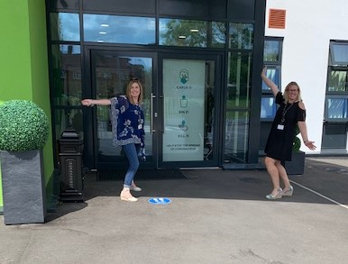
REMINDER
Attendance is compulsory. Parents may be fined if they do not send their children back to school in September.

