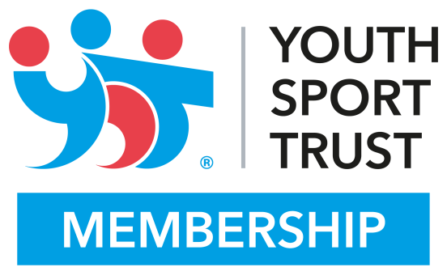

WEST HEATH PRIMARY SCHOOL ACHIEVES YOUTH SPORT TRUST GOLD QUALITY MARK

WESTHEATH PRIMARY SCHOOL in Birmingham has been awarded the Youth Sport Trust GOLD Quality Mark for its commitment to physical education (PE) and school sport at its school. The Youth Sport Trust is a national charity that builds a brighter future for young people through the power of sport.
The Quality Mark is an online self-review tool which provides schools with a nationally recognised badge of excellence for the quality of its PE and school sport. The tool supports schools to audit their PE provision and identify priorities for its development.
Mrs Hooper said:
“We are absolutely thrilled to have been awarded the GOLD Quality Mark from the Youth Sport Trust, which recognises our commitment to delivering the best possible sporting experiences for the young people at our school.
“There are a whole range of educational, health and wellbeing benefits from delivering high quality PE and school sport, and we see on a regular basis that when it is delivered well it can transform the lives of all pupils.”
Schools are awarded Bronze, Silver and Gold status, which reflects its efforts in using PE and school sport to raise achievement across the school. When a school is awarded the Gold Quality Mark, the Youth Sport Trust has visited the school to validate its self-review.
Alison Oliver, Chief Executive at the Youth Sport Trust, said:
“Congratulations to WEST HEATH PRIMARY for achieving the Youth Sport Trust GOLD Quality Mark. Schools which achieve the Quality Mark, share our belief in the value of high quality PE and sport and the positive impact it has on young people’s journey through education.
“PE and school sport helps young people to live healthy and active lives and through it, helps them achieve their personal best in school and life. We are delighted to be working with thousands of schools across the country that recognise the competitive advantage this gives to their pupils.”
ENDS

Notes to Editors:
For further information contact: Adam Hooper Sports Coordinator
Youth Sport Trust press office: 01509 226317
Youth Sport Trust: Wellbeing. Leadership. Achievement.
The Youth Sport Trust is a national charity that is building a brighter future for young people through PE and sport. Through 20 years of experience we have developed a unique way of maximising the power of sport to grow young people, schools and communities through the development of qualities including creativity, aspiration, resilience and empathy.
Find out more by visiting www.youthsporttrust.org
The Quality Mark took has been aligned to Ofsted guidance supporting the PE and Sport Premium and comprises a series of straight forward benchmarking statements, where schools can select their level of provision in areas including:
- Overall vision of PE, physical activity and school sport
- Quality of PE
- Quality of school sport
- Quality of physical activity
- Use of PE, physical activity and sport as a catalyst for wider learning

