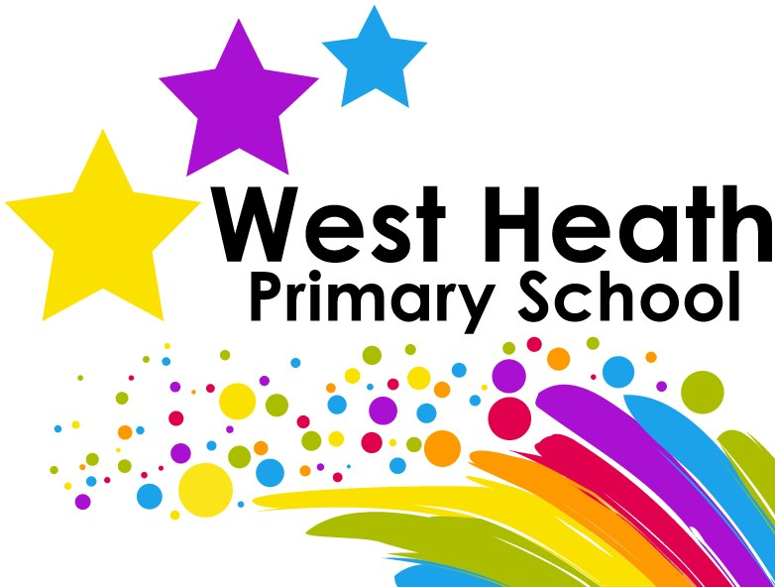

Music Curriculum Policy

Safeguarding Statement
West Heath Primary will continuously strive to ensure that everyone in our school is treated with respect and dignity. Each person in our school will be given fair and equal opportunity to develop their full potential with positive regard to gender, ethnicity, cultural and religious background, sexuality or disability. West Heath Primary School is committed to safeguarding and promoting the welfare of children and young people and expects all staff to share this commitment.

Owner | Music Co-ordinator
Date of review | February 2024
Date of next review | July 2024

Music Curriculum Policy

Audience
This policy has been written so that all staff follow our expectations for our interpretation of the Music National Curriculum.

Music Curriculum Intent
The intent for the music curriculum is to enthuse, engage and inspire children through a high quality, sequenced and enriched music curriculum. We want children to have high aspirations for themselves and their future, to prepare them for life after primary school and to support them in developing the core values that we think will help them to succeed. At West Heath we champion every child to, ‘Be a Star Shine Bright!’

Music Curriculum Implementation

We teach music weekly. Each lesson is taught by the class teacher and uses the Charanga scheme of work to deliver the curriculum. With a focus on the dimensions of music (pulse, pitch, dynamics, rhythm, texture and tempo) as well as listening to, improvising, singing and composing music, we plan to provide our children with a quality, enriched and engaging music education. Alongside this, we also offer whole class instrumental teaching for Year 4 where they can learn a musical instrument and develop important musical skills to support with upper phase curriculum music. The children are then offered an opportunity to continue with their musical tuition as an elective in Upper school.

Curriculum Impact

At West Heath our Music curriculum will develop an understanding of culture and history, both in relation to students individually, as well as ethnicities from across the world. Our Children will be able to enjoy music, in as many ways as they choose- either as listener, creator or performer. They will be able to dissect music and comprehend its parts. They will be able to sing and feel a pulse. They will have an understanding of how to further develop skills less known to them, should they ever develop an interest in their lives.

Organisation

- EYFS

Personal, social and emotional development
Communication and language
Understanding of the world
Expressive arts and designs

We encourage creative work in the reception class as this is part of the Foundation Stage of the National Curriculum. We relate the creative development of the children to the objectives set out in the Early Learning Goals, which underpin the curriculum planning for children aged three to five. The children’s learning includes music, dance, and imaginative plan. The range of experience encourages children to make connections between one area of learning and another and so extends their understanding.

Weekly singing assemblies
Christmas and end of year performances
Weekly music lessons taught using Charanga
Access to instruments through continuous provision
Singing of nursery rhymes throughout the day

- KS1

Encourage learning of Music primarily through singing and composition using instruments.
Immerse children with different types of Music throughout the academic year.

Christmas performance
Weekly singing assemblies
Weekly Music lessons taught using Charanga

- KS2

Music is taught primarily in three chunks:

- Listen and Appraisal of Music
- Music Theory- Key musical vocabulary
- Music Performance- Using tuned and un-tuned instruments

Christmas performance
Weekly singing assemblies
Weekly Music lessons taught using Charanga
Whole class instrumental lessons (Services for Education)

Curriculum maps

KS1:

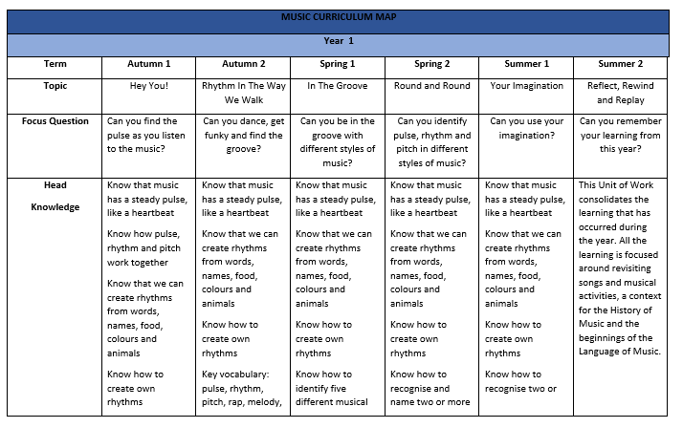
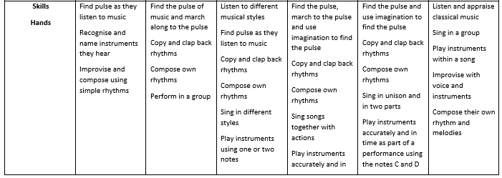
- Encourage learning of Music primarily through singing and composition using instruments
- Immerse children with different types of Music throughout the academic year

KS2:

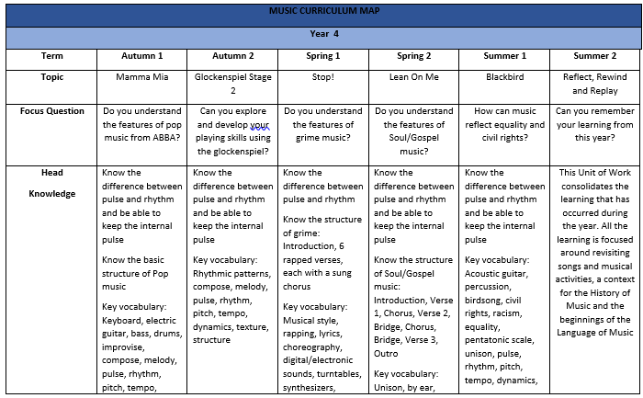

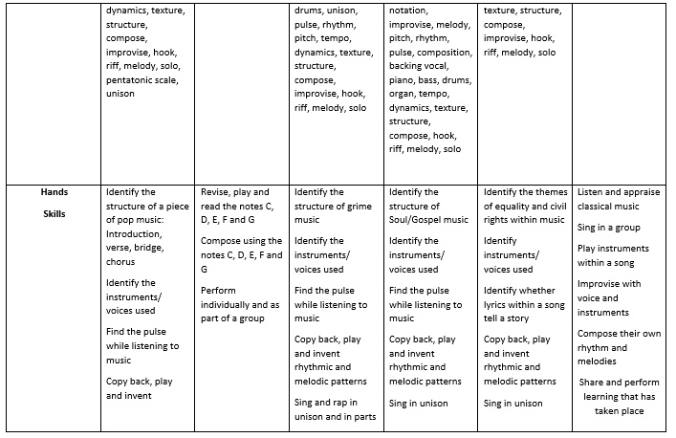

Teach Music in three chunks:
- Listen and Appraisal of Music
- Music Theory- Key musical vocabulary
- Music Performance- Using tuned and un-tuned instruments

Assessment

Music is planned progressively using the curriculum map. This is evident through the use of key vocabulary and specific success criteria to allow children to learn and understand the vocabulary and terminology for the unit of work they are focusing on.
Teachers should use formative assessment to assess the progress of children across a block of learning. Teachers should assess by importing data (mp3s and videos) on to Charanga.

Inclusion

At West Heath, we teach Music to all children, whatever their ability, in accordance with the school curriculum policy of providing a broad balanced education to all. Teachers provide learning opportunities matched to the needs of children with learning difficulties and our work in the arts takes into account the targets set for individual children in their individual educational plans.

Role of the subject leader

The music co-ordinator is responsible for the standard of music at West Heath Primary School and for the quality of teaching. The subject coordinators also support colleagues in the teaching of Music. The Music co-ordinator is responsible for completing termly action plans to strengthen and develop their subject.

Review

This policy will be reviewed, each academic year, by the Music co-ordinator, to ensure it reflects changes made to the curriculum policy and curriculum maps that are followed to teach Music across the curriculum.

