Early Years Foundation Stage Policy

Safeguarding Statement
West Heath Primary will continuously strive to ensure that everyone in our school is treated with respect and dignity. Each person in our school will be given fair and equal opportunity to develop their full potential with positive regard to gender, ethnicity, cultural and religious background, sexuality or disability. West Heath Primary School is committed to safeguarding and promoting the welfare of children and young people and expects all staff to share this commitment.

Owner | EYFS Leader
Date of review | December 2020
Date of next review | December 2021
Owner’s Signature

  - “Early years provision is only as good as the quality of interaction between adults and children.” (Sir Michael Wilshaw )

  - Our Philosophy
  - The philosophy of our provision at West Heath Primary School underpins a curriculum founded on play; it is supported by a high-quality caring environment and provides a broad framework, in order for all children to learn effectively. Children need a relevant curriculum which is well planned, offers purposeful activities both indoors and outdoors and one which is structured in content, to take into account the differing interests, backgrounds and abilities of our children. Allowing opportunities to explore, experiment, plan and make decisions for themselves.
  - We believe that learning in the early years is holistic.
  - The individual needs and interests of children are at the heart of our curriculum. We are committed to play based, active learning inspired by children’s interests. We know that a rich, enabling environment encourages children to take ownership of their own learning which promotes higher levels of involvement.
  - Our work has, at its core, the aim of enabling children to develop their emotional, social, cognitive, interpersonal and physical skills, and their desire to explore, discover and be creative. We believe that children who are confident in themselves and their own ability have a head-start to learning, we therefore ensure that all our pupils feel included, secure and valued.

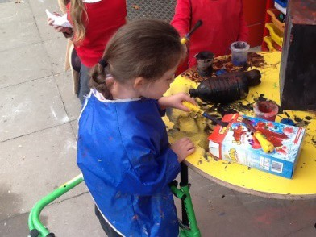
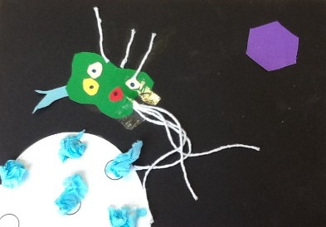
  - The Curriculum

At West Heath Primary we follow the EYFS Early Adopter framework (2020). Within this framework there are four guiding principles which shape are practice.
These are:
- Every child is a unique child, who is constantly learning and can be resilient, capable, confident, and self-assured.
- Children learn to be strong and independent through positive relationships.
- Children learn and develop well in enabling environments with teaching and support from adults, who respond to their individual interests and needs and help them to build their learning over time. Children benefit from a strong partnership between practitioners and parents and/or carers.
- Children develop and learn at different rates. The framework covers the education and care of all children in early years provision, including children with special educational needs and disabilities (SEND).
Our curriculum encompasses the seven areas of learning and development. All areas of learning and development are important and inter-connected. Three areas are particularly important for building a foundation for igniting children’s curiosity and enthusiasm for learning, forming relationships, and thriving.

These are the Prime Areas:
• Communication and Language
• Personal, Social, and Emotional Development
• Physical Development

Staff also support children in four specific areas, through which the three prime areas are strengthened and applied.

The Specific Areas are:
• Literacy
• Mathematics
• Understanding the World
• Expressive Arts and Design

Included throughout our early years curriculum are three Characteristics of Effective Teaching and Learning.

These are:
- Playing and Exploring - children investigate and experience things, and ‘have a go’
- Active Learning - children concentrate and keep on trying if they encounter difficulties, and enjoy achievements
- Creating and Thinking Critically - children have and develop their own ideas, make links between ideas, and develop strategies for doing things
These elements underpin how we reflect on each child’s development and adjust our practice accordingly. Supporting children in their individual learning behaviour and observing the context of children’s play is essential.

‘What children learn is important, but how children learn is even more important if they are to become learners in today’s society.’
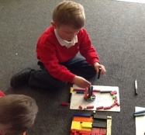
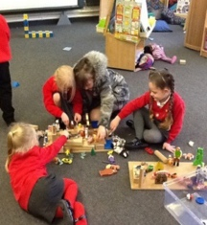
(Helen Moylett, How Children Learn, Nancy Stewart 2011)

  - At West Heath Primary School, we strongly believe that children learn best when they are in an environment in which they feel safe and secure. We encourage children to take risks both physically and emotionally; knowing that they are in an emotionally secure environment with adults whom have a good knowledge and understanding of their individuality enables children to build resilience.
  - Enabling Environments
  - In our Early Years environment, the children initiate their own learning and adults join them and support them in their activities. In order to support genuine choice, we have a workshop style environment setup.
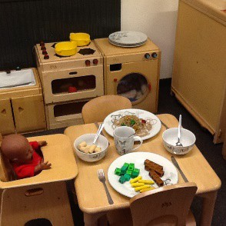
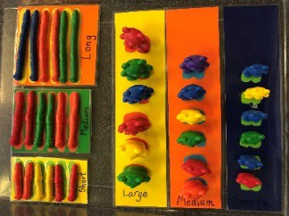
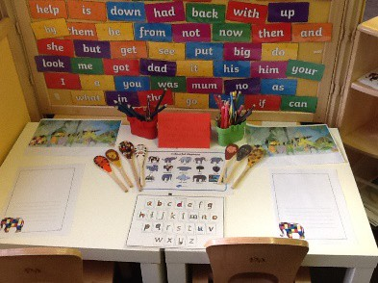
  - In all areas, the resources are available and accessible to the children at all times. The areas are clearly labelled, tidy and well stocked.

  - The labelling of resources is a key element of our philosophy in EYFS . All resources are labelled to develop independence during tidy up time and to create independent learning opportunities within the environment, allowing children to explore, shapes, sizes, quantities, values and problem solving.
  - As the children become confident with their environment and resources, the staff will change and substitute the resources for more complex challenges, for example word problems or shape names. This will ensure that the children are continuously independently accessing challenge and stimulation from their immediate environment.
  - Tidy up time is independently undertaken by the children. This process isn’t rushed as it is a key learning opportunity. Children have to ensure that ; the correct number of pencils are returned to the pots; all of the different shaped bricks are put back correctly and everything is returned to its rightful home. This not only teaches children about taking responsibility for what they use, but also encourages mathematical discussions. For example, ‘we are supposed to have 6 red pencils, but we only have 4, how many are missing?’

  - The resources (as well as the areas) are assessed and reviewed constantly with changes made as necessary. If an area or a resource is not engaging children in purposeful play, it is removed or changed. Likewise, if the children are not tidying up a certain area properly or respecting the resources available then the area will be closed for the rest of the day whilst expectations are reinforced.
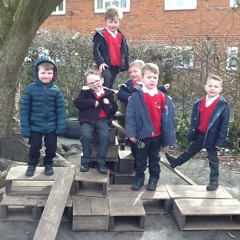
  - Children have access to both the inside and outside areas throughout the day.
  - One of the many benefits of outdoor learning is allowing children to take
  - controlled risks and teaching them to become competent risk assessors. At West Heath Primary School, we strongly believe that children need to learn this essential skill for lifelong learning.

  - Enabling Environments - Adults
  - Adult scaffold and extend the children’s learning. They do this through observing, interacting and being part of sustained shared thinking.
  - Adults seek the ‘teachable moment’ whilst the children are engaged, they have a sound understanding of child development. This ensures that the adults enhance and extend the learning at the appropriate level for each unique child. The children become involved in activities of their choice. The adults observe the children carefully; join them, when appropriate, and engage in quality interactions to move the learning on. They “teach” through modelling, suggesting, providing vocabulary or resources, explaining or encouraging. In this way, if a child encounters a challenge they will be supported to persevere, overcome the challenge and move forward in their learning.
  - “The environment should act as an aquarium which reflects the ideas, ethics, attitudes and cultures of the people who live in it!” (Loris Malaguzzi)
  - To ensure that the environment is safe an internal and external risk assessment is completed each day by a member of the Early Years team. Any issues are reported caretaker’s book and signed off once completed.

  - The Reception Year
  - Transition – Starting School
  - At West Heath Primary School, we have an extensive transition programme, that promotes a positive and successful transition for both child and parents. In the summer term, before the children start school, members of the Reception Team visit the children in their settings e.g. nurseries and childminders. In this way contact is established with key workers and information can be passed on.
  - Reception teachers also carry out home visits in the summer term. This allows information to be passed on to parents and carers and gives them the opportunity to ask questions and share knowledge or any concerns they have about their children. This also gives each child the security of meeting with staff in a safe, familiar environment.
  - In addition, in the summer term, children have the opportunity to attend a ‘stay and play’ session at school. During these sessions’ children can familiarize themselves with their new setting and build relationships with the early year’s practitioners.
  - September
  - At the beginning of the school year children begin school on a staggered basis; this lasts for three weeks. They will meet the EYFS team, in small groups, through morning and afternoon sessions. The EYFS team will begin to baseline the children during these sessions.
  - Children will be taught the school rules, routines and values.
  - Parents will be invited to attend a stay and play session to familiarize themselves with the EYFS staff and environment.
  - We have found this enables the children to settle extremely quickly and reduces child and parent anxieties.
  - Children will be assigned to a class after this period of settling in; this will enable us to ensure that children are grouped appropriately.
  - October/November
  - Once all children are settled into their environment, we invite parents and carers into school in the mornings to support their children with reading, writing and maths. These sessions will run from 8.30am – 8.50am.
- Each class will also have two PE lessons each week.
- Each child will receive 1:1 reading support at least once each week.
- Phonics lessons take place each day using Read Write Inc.
- There is a maths session each day.

  - Rules and Routines
  - Tidy up music is played regularly so that children have the opportunity to practice their maths skills and to develop independence.
  - At the start of the day, children hang their coats up, put their reading book and drinks bottle in the designated space and sit on the reading or practicing name writing whilst the register is taken.
  - This is then followed by the teacher explaining to the children what they will be learning that day and what resources are available out to support learning.

  - Parents as Partners
  - At West Heath Primary School, we value relationships with parents. We acknowledge the children’s experiences at home and appreciate that these are highly significant to their achievement in school.
  - We use Tapestry to keep parents informed of their child’s developments. Regular observations of what their children are learning at school and possible next steps are shared with parents. We also encourage parents to add their own observations and photographs from home. This insight into a child’s home life is invaluable and can lead the learning that takes place within school.
  - In addition, all staff are available at the end of each day to establish partnership with our families.
  - Throughout the year parents and carers are also invited to join their children in various learning workshop opportunities, including phonics, maths, WOW days and many more.
  - At the end of the summer term parents will receive a report outlining their child’s attainment and a short commentary about their child’s skills and abilities in relation to the three key characteristics of effective learning.
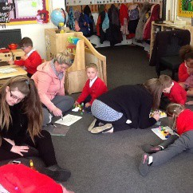
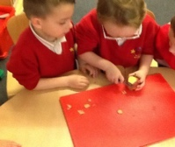

  - Assessment
  - Baseline assessments begin as soon as we meet our new cohort in their nursery settings and during the home visits in the summer term. They are completed within the first four weeks of the children entering school and the EYFS staff will use their professional judgement to assess the age band children are working ‘within’ across the EYFS 17 areas of learning. Children will then be given a ‘baseline’ assessment and these results are recorded on Tapestry . Assessment in the Early Years is based on the adult’s knowledge of child development, in line with statutory regulation.
  - Formative Assessment
  - As part of our daily practice we observe and assess children’s development and learning to inform future planning and teaching. We record observations online using Tapestry learning journals. Over time observations are made in different learning contexts and at different times of the day to cover the breadth of learning opportunities. Written observations, photos and drawings all contribute to the summative report.
  - Our aims are to ensure that the starting point for assessment is the child and not a predetermined list of skills. Observations show what the child can do – significant achievements – not what they can’t do.
  - Each week, teachers analyse Tapestry to identify gaps in the children’s learning and highlight which areas of learning and which children need to be the focus in the following week. The staff will use this information to select resources and activities to stimulate the children’s interest and scaffold their learning.
Teachers also draw on their knowledge of the child and use their own expert professional judgement when assessing.
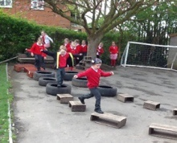

  - Reporting at the end of the EYFS
  - In the summer term a Reception child’s Learning Journey is completed. It provides parents and carers, practitioners and teachers with a well-rounded picture of a child’s knowledge, understanding and abilities, their progress against expected levels, and their readiness for Year One.
  - Each child’s level of development is assessed against the early learning goals. Teachers indicate whether children are meeting the level of development expected at the end of the EYFS (expected); or not yet reaching this level (emerging).

  - Transition – Moving to Year 1
  - Towards the end of the Reception year, children meet with their new teachers and spend time with them in their new classrooms prior to starting Year One.
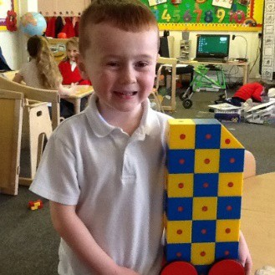
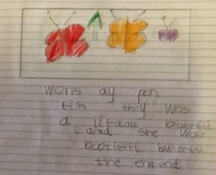
  - Parents/carers are also invited into school to visit their child’s new classroom and meet the Year 1 teachers. Reception staff meet with Year 1 teachers and pass on reports and key information about the children moving on.

Monitoring
This policy will be monitored by the Senior Leadership Team. It will be reviewed biannually.

