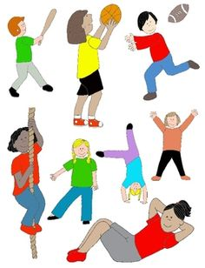 

**P.E**

**Your PE days are;**

**Class 1 (Red & Yellow Group) -Thursday  
Class2- (Green & Blue Group) - Tuesday**

**Please remember to come to school in your full kit.**

**Homework**

**Daily Reading**

**– to be recorded in the planner every evening.**

**Homework will be given out every Thursday and will be collected in on the following Tuesday.**

**This will commence on the 27th September.**

**Each week homework will alternate between a Literacy and a Maths focus.**

**Meet the staff!  
Miss Lippett  
Mrs Whitehouse  
 Mrs Baker  
Mrs Ellis  
Mr Hooper(Coach Adam)**

**Sports Coaches from Get Sports Active.**

 Welcome to Reception

**Throughout the course of the year, what the children learn in Reception will vary based on their own interests. In Reception we take a child-initiated approach to learning and will adapt our plans to the needs and interests of your children. We are delighted with how the children have settled into school and feel sure that we are going to have a great year!**

**What will my child be learning this half term?**

**In Reception we will be reading the story of ‘Elmer’ to celebrate how unique we all are. This is a great way to help the children continue to settle into school.**

**Elmer will be helping us to;**

* **Make new friends**
* **Learn about our differences**
* **Recognise our numbers to 10**
* **Count objects all around us**
* **Create patterns with colours**
* **Re-tell stories**
* **Learn our sounds**
* **Hear sounds in words**
* **Form our letters**
* **Make collages using different materials**
* **Learn about different animals and their habitats**
* **Explore the world around us**
* **Move and dance like animals**