Remote Learning Policy for Parents

Safeguarding Statement
West Heath Primary will continuously strive to ensure that everyone in our school is treated with respect and dignity. Each person in our school will be given fair and equal opportunity to develop their full potential with positive regard to gender, ethnicity, cultural and religious background, sexuality or disability. West Heath Primary School is committed to safeguarding and promoting the welfare of children and young people and expects all staff to share this commitment.

Owner | Head Teacher
Date of review | November 2020
Date of next review | November 2021

Audience
All members of West Heath Primary School should read and understand this policy.

Aims
This remote learning policy aims to:
- Ensure consistency in the approach to remote learning for pupils who aren’t in school.
- Set out expectations for all members of the school community with regards to remote learning.
- Provide appropriate guidelines for data protection.

Roles and responsibilities
The following information will outline the expectations of Teachers, Teaching Assistants and the senior leadership team, in relation to remote learning.

Teachers
When delivering remote learning, teachers must be available from 8.30- 3.30. If they are unable to work for any reason during this time, for example due to sickness or caring for a dependent, they should report this using the normal absence procedure.

The following will outline what is expected of Teachers in relation to potential scenarios: Pupils who are self-isolating; teachers who are self-isolating and completely class isolation.

Pupils who are self-isolating (individual cases):
Teachers are expected to provide work for children in their class that are having to self-isolate due to track and trace. In this instance, the office will inform the class teacher that a child is self-isolating.

Teachers must:
- Send a PING to parents outlining how work will be set.
- Establish which children have access to Microsoft Teams and set work via the learning platform(see Appendix 1).
- For those children who do not have access to Microsoft Teams, work should be sent via PING. There is no requirement to send work via PING and Microsoft Teams.
- Ensure that work set includes:
  - A daily Maths lesson. These should include the White Rose video and worksheets, where appropriate.
  - A daily English lesson.
  - A daily Reading based activity.
  - A topic/Science based lesson that relates to the work that the children are completing in school.
  - Signposting the children to daily physical activity.

Teachers who are self-isolating
In the event of a teacher having to self-isolate, the Teacher will continue to deliver
lessons through Microsoft Teams. A HLTA and where possible a TA (as per the cover plan)
will be in the classroom to facilitate learning and undertake basic marking of the children’s
work.

At the point that a Teacher goes into self-isolation they must:
- PING the parents to inform them that they are self-isolating due to track and trace.
- Plan and deliver all lessons as per their usual timetable. Teachers must deliver lessons via Microsoft Teams using screen share: PowerPoint is the most effective tool.
- Liaise with the HLTA responsible for their class and ensure that they have all of the resources needed for all lessons.

Whole class Isolation
In the event of whole class isolation, Teachers will be expected to continue to teach their class via Microsoft Teams. Work will also need to be set and marked using this platform.

At the point the class goes into isolation teachers must:
- Send an introductory PING explaining how remote education will work. This will include an outline of the expectations to use Microsoft Teams and the class temporary email address for the period of isolation.

For every subsequent day of isolation, teachers must:
- Ping the parents every evening by 7pm with a timetable for the following day.
- Teach four lessons per day- English, Maths, Guided Reading and a topic/Science lesson via Microsoft Teams and set work based upon these lessons.
- Mark all work completed by the children and return it to them with feedback.
- Signpost children to daily exercise activities.
- Check their class email account and respond to parental concerns as required.

- The PE staff in line with the class timetable will teach PE virtually.

For all virtual lessons, Teachers must ensure that they are appropriately dressed and that they are teaching from an area, which is free from noise and has nothing inappropriate displayed in the background.

Teaching Assistants
When assisting with remote learning, Teaching Assistants must be available for work during their usual contracted hours. If they are unable to work for any reason during this time, for example due to sickness or caring for a dependent, they should report this using the normal absence procedure.
When assisting with remote learning, Teaching Assistants are responsible for:
- Making a phone call to all of the children in the class on day one of isolation to ensure that they have the resources necessary to partake in online lessons and feedback any issues to SLT.
- Making a well-being call to all children on day seven of the pupil’s isolation. If this falls at the weekend the call can be made on the Friday before.
- Logging into each online lesson and keeping a register of who has attended the session.
- Emailing the session attendance to the class teacher.
- Finding appropriate resources as directed by the teacher.
For all virtual lessons, Teaching Assistants must ensure that they are appropriately dressed and that the area in which they are teaching is free from noise and that nothing inappropriate is displayed in the background.
At the point that a ‘bubble’ is sent home to isolate, SLT will ensure that Teaching Assistants have the appropriate resources to be able to support the teacher and class during the isolation period. Equipment will be loaned, should it be necessary.

Senior Leaders
Senior leaders are responsible for:
- Co-ordinating the remote learning approach across the school by ensuring that all Teachers and Teaching Assistants have the resources necessary to deliver remote education.
- Monitoring the effectiveness of remote learning, by liaising with the staff delivering the remote learning and acting upon feedback.
- Monitoring the security of remote learning systems, including data protection and safeguarding.
- Identify children who do not have access to technology and loaning equipment to them.

Information Technology staff
Information Technology staff are responsible for:
- Finding solutions to issues with the systems used to set and collect work.
- Helping staff and parents with any technical issues they are experiencing.
- Reviewing the security of remote learning systems and reporting any data protection breaches to the Data Protection Officer.
- Assisting pupils and parents with accessing the internet or devices.

Pupils and Parents
Staff can expect pupils learning remotely to:
- Be available during the school day – although they will consider that children may not always be in front of a device the entire time.
- Complete work to the deadline set by Teachers.
- Seek help if they need it, from Teachers or Teaching Assistants
- Alert Teachers if they are not able to complete work.

Staff can expect parents with children learning remotely, to:
- Make the school aware if their child is sick or otherwise cannot complete work.
- Seek help from the school if they need it.
- Follow the school’s complaints policy should the need arise.
- Refer parents to Parent ‘s Guide(Appendix 2)

Governing Body
The governing board is responsible for:
- Monitoring the school’s approach to providing remote learning in line with DfE expectations.
- Monitoring the school’s procedures for safeguarding during remote learning.

Safeguarding
Teachers and Teaching assistants must ensure that they report any safeguarding concerns using the school’s MY CONCERN system.

The Teacher is responsible for monitoring which children have accessed work.
- If children have not accessed work on day 1, a PING message reminding parents of the timetable must be sent.
- If work has not been opened and completed on day 2, a phone call should be made to parents.
- For parents who state that they do not have access to technology or the internet, the Family Support Worker should be informed. Where possible, technology will be loaned to the parent for the period of time that the child is isolating.
- If on day 3, work has not been opened and completed, the Family Support Worker must be notified, and a safe and well check will be undertaken.

Monitoring and Review
This policy will be reviewed by SLT to ensure that it reflects the current situation, both in school and nationally.

APPENDIX 1

Remote Learning Internet Safety

In order to make sure that your child stays safe online, we ask that you support them in the following:
- Access Microsoft Teams through your child’s account.
- An appropriate adult: a parent or carer will remain close by during calls to help, if needed.
- Your child must take part in the video call in a suitable communal environment (not a bedroom) and be appropriately dressed (uniform isn’t necessary, but they should be fully dressed in clothing that would be appropriate to wear to school, e.g, on a non-uniform day.)
- All members of the household must be aware that the call is taking place and make sure they use appropriate language and behaviour when nearby or in the background.
- Make sure your young member has ‘logged off’ the call correctly and signed out before turning off any devices.
- Parents or children should not try to contact any staff using these online tools outside of the pre-arranged calls.
- If you need to contact a member of staff for any reason you will do so following your normal contact procedures (i.e. emailing or calling the school office).

In order to protect your child, we will:
- Have a member of staff present throughout the video call who will stay on the call until all children have ‘logged off’.
- No member of staff will contact you outside of any pre-arranged meetings using these online tools
- If they do need to contact you will do so following the normal contact procedures (i.e. phone call or School Ping)
- All members of staff will ensure they are in a communal living space throughout the call. They may blur the background in any video calls.

APPENDIX 2

Parent Guide to Microsoft Teams

There is a tab called ‘Class Notebook’
If you click on this tab you will open the notebook.

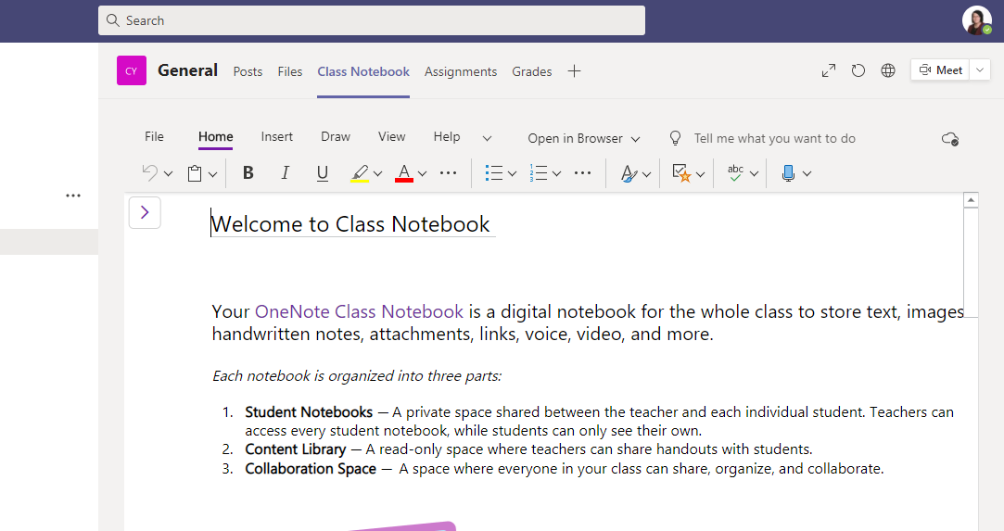
If you then click on your child’s notebook, he will then have a selection tab at the side that looks like this.

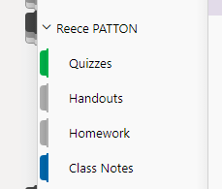
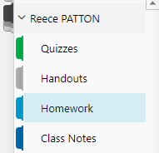
Once you are in your child’s personal notebook, click onto his homework page tab.

You will then see this page

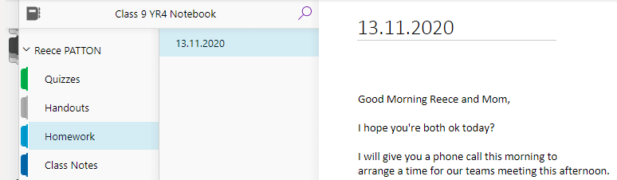

You can just type on this page and it will automatically save, you do not need to send anything.
**The only issue with this communication method is there are no notifications. I will keep this page open throughout the day and check-in during break and lunch times.
I have already popped a message in there, so that it is set up and ready to go.
I hope this helps, if there are any issues we can discuss them during our call later.
Best Wishes

